Simple Moments Photography
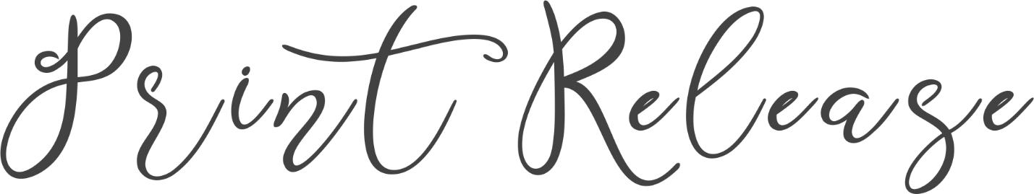
This letter gives restrictive permission to reproduce, display, distribute, and or use the copyrighted photographic material for personal use only. You may not distribute, duplicate, and/or use the copyrighted material for advertising and/or commercial use. You may not edit, modify, or create derivative works of the copyrighted material without citation to the originator of the material. Please note that this form only grants permission to print. Copyright ownership remains with the photographer.
I hereby grant permission for use of the copyrighted material as specified above.
Amanda Whitley _________________________________________________________09/12/19_
E-Signed, photographer date
918.794.8455
Amanda@simplemomentstulsa.com
@simplemomentstulsa @simplemomentstulsa @simplemomentstulsa

